Name: Justine Nino B. Cubelo Prog. & Yr.: BSIT 3
Section: 2 Subject: WS 301

WS 301 - Performance Task
Form Validation

Student Registration Form

Explanation:

My Student Registration Form allows students to enter their personal information, school details, password, and address. I used JavaScript to check if the required fields are filled in and if the email, phone number, and passwords are correct. I also used preventDefault() to stop the form from submitting right away so the information can be checked first. If there is something wrong or missing, an error message will appear below the field so the user knows what to fix. I used classList.add() and classList.remove() to add and remove the red error styling when a field is invalid or corrected. I also used classList.toggle() for the show and hide password button. For the data-* attributes, I added information to the form fields and accessed it in JavaScript using dataset. I also changed the password field's type attribute from password to text when the user clicks the show password button. Once all the information is correct, the form displays a success message, and the reset button clears the entered details and errors.

Screenshots:
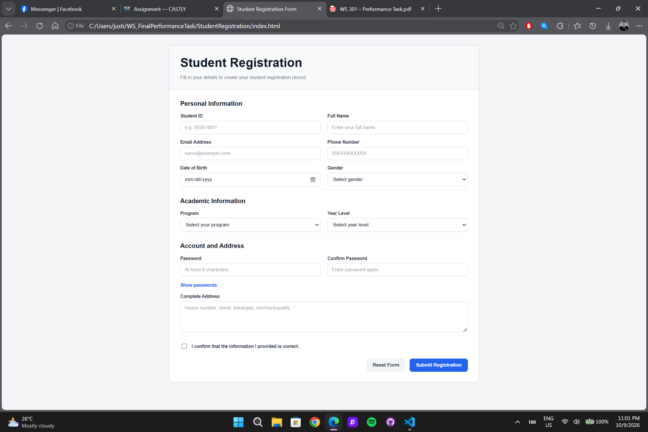
Initial Form

Validation Errors
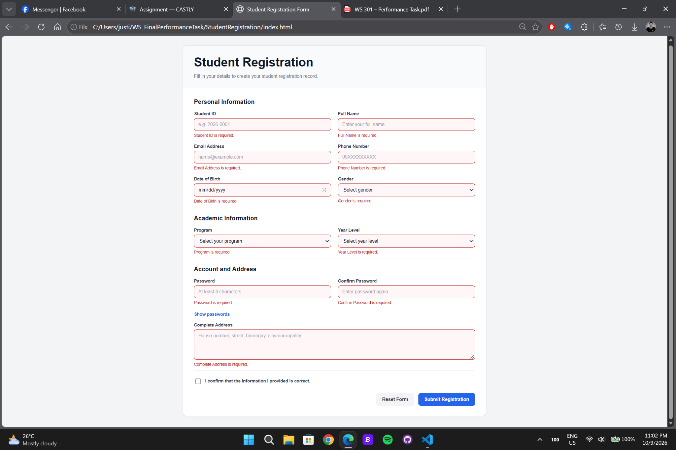

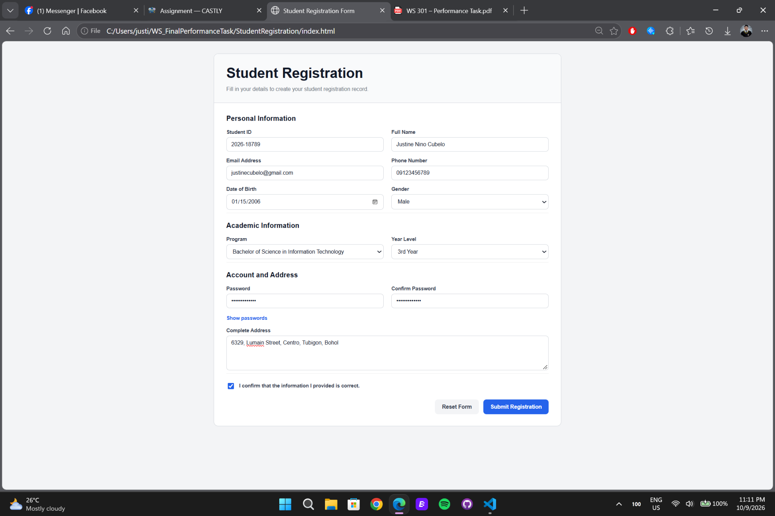
Corrected Form

Successful Form
